Introduction to Threads

<https://www.youtube.com/watch?v=LOfGJcVnvAk>

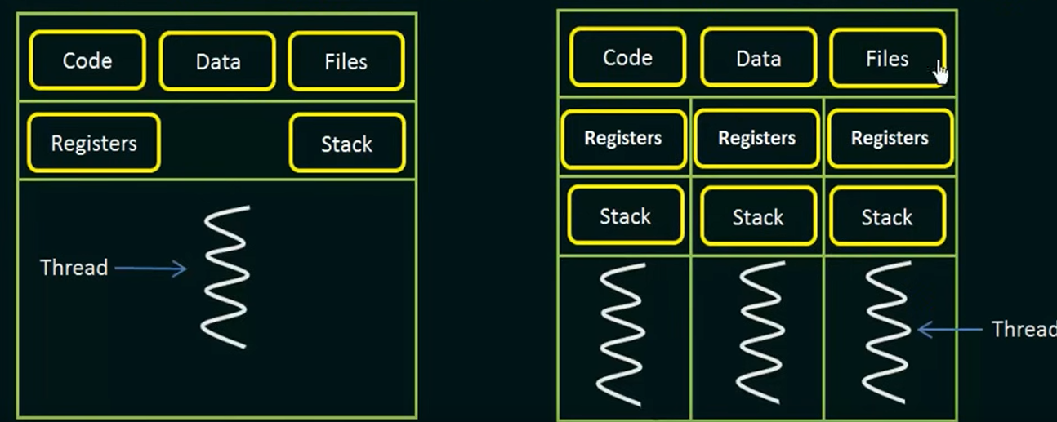

<https://learn.microsoft.com/en-us/sysinternals/downloads/process-explorer>